**31-07-24:**

**PreProd-Management Portal Bug List:**

1. Report- Scheduling Tracker (beta)-Goal Setup-In Webtable, in heading of the webtable edit colum alginment is not proper.

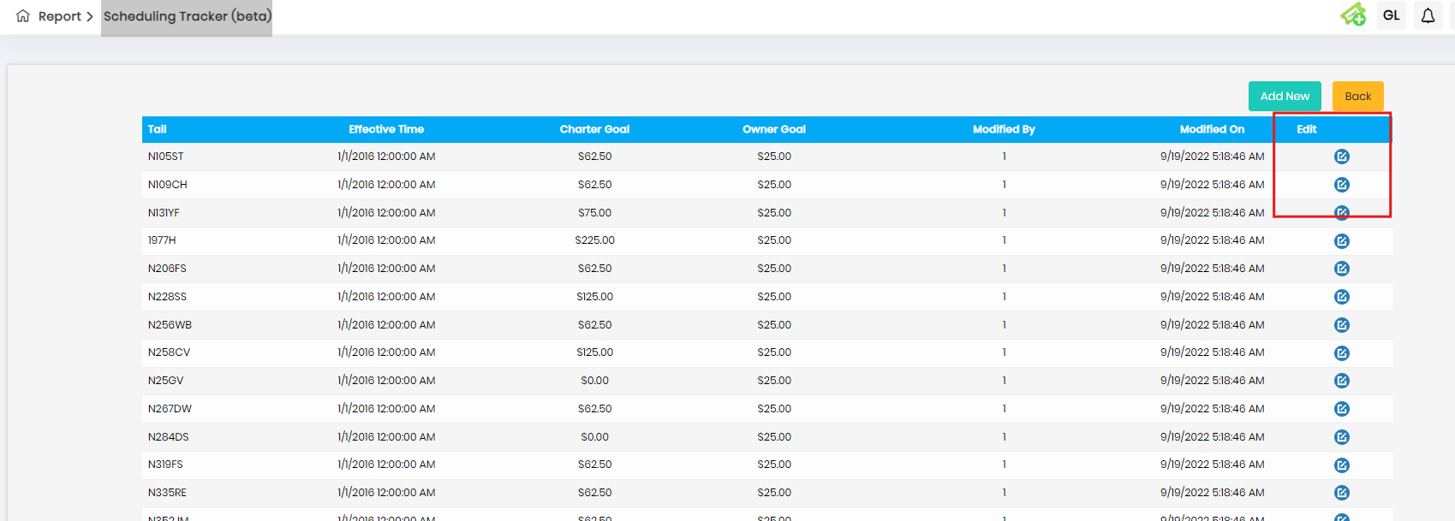

1. Report- Scheduling Tracker (beta)-Goal Setup-Add New-Without enter any values and click save button alert message is displayed. But in the alert message data displayed 2 times.

* And also 2 alert message is displayed

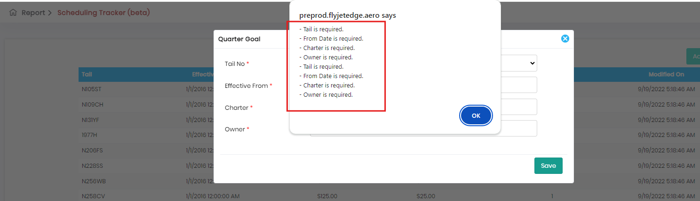

1. Report- Scheduling Tracker (beta)-Goal Setup-Add New-Enter valid details in Tail No and Effective from, After that enter invalid details in Charter and Owner tab like enter alpha characters and click save button, no message is displayed.
2. Report- Scheduling Tracker (beta)-Goal Setup-Add New-Enter valid details in every field data gets updated successfully but no message is displayed.
3. Report- Scheduling Tracker (beta)-Goal Setup-Click Edit button-After modify valid details and click update button data gets saved, but in web table, “Modified By” column displayed numeric values but It need to show user details.

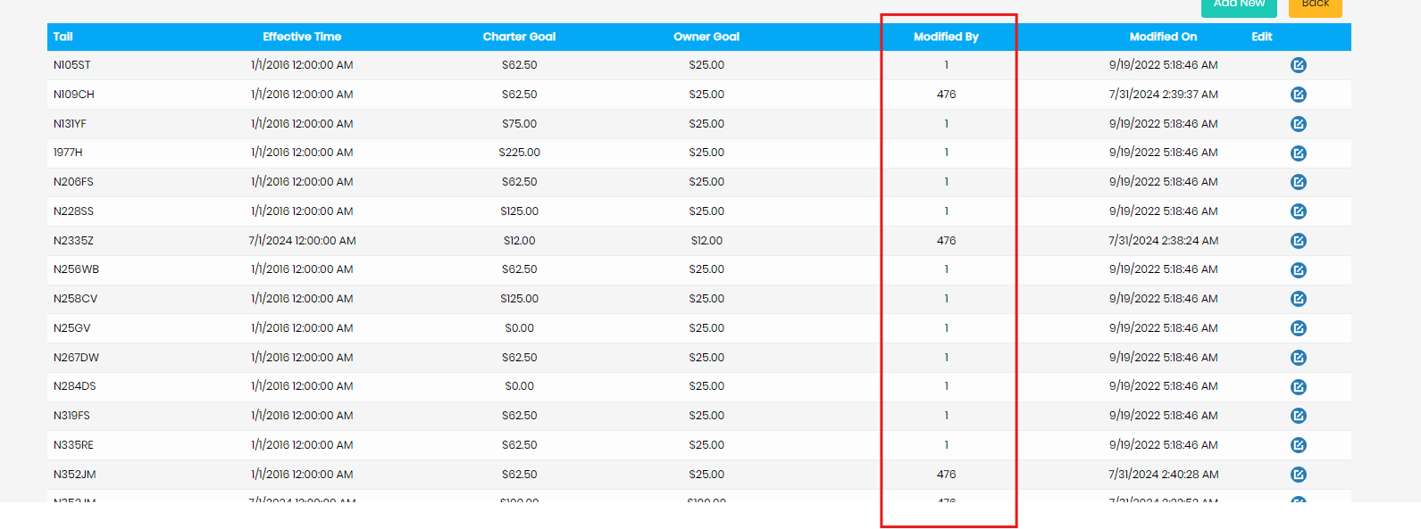

6.Report- Scheduling Tracker (beta)-Goal Setup-Add New-Select valid tail and without enter any other details in other tab and only click close button and again click add new button, tail no displayed previously selected value, but it need to display “Please Select” option.